G17 - Overall system COMP6030

1a) Use case model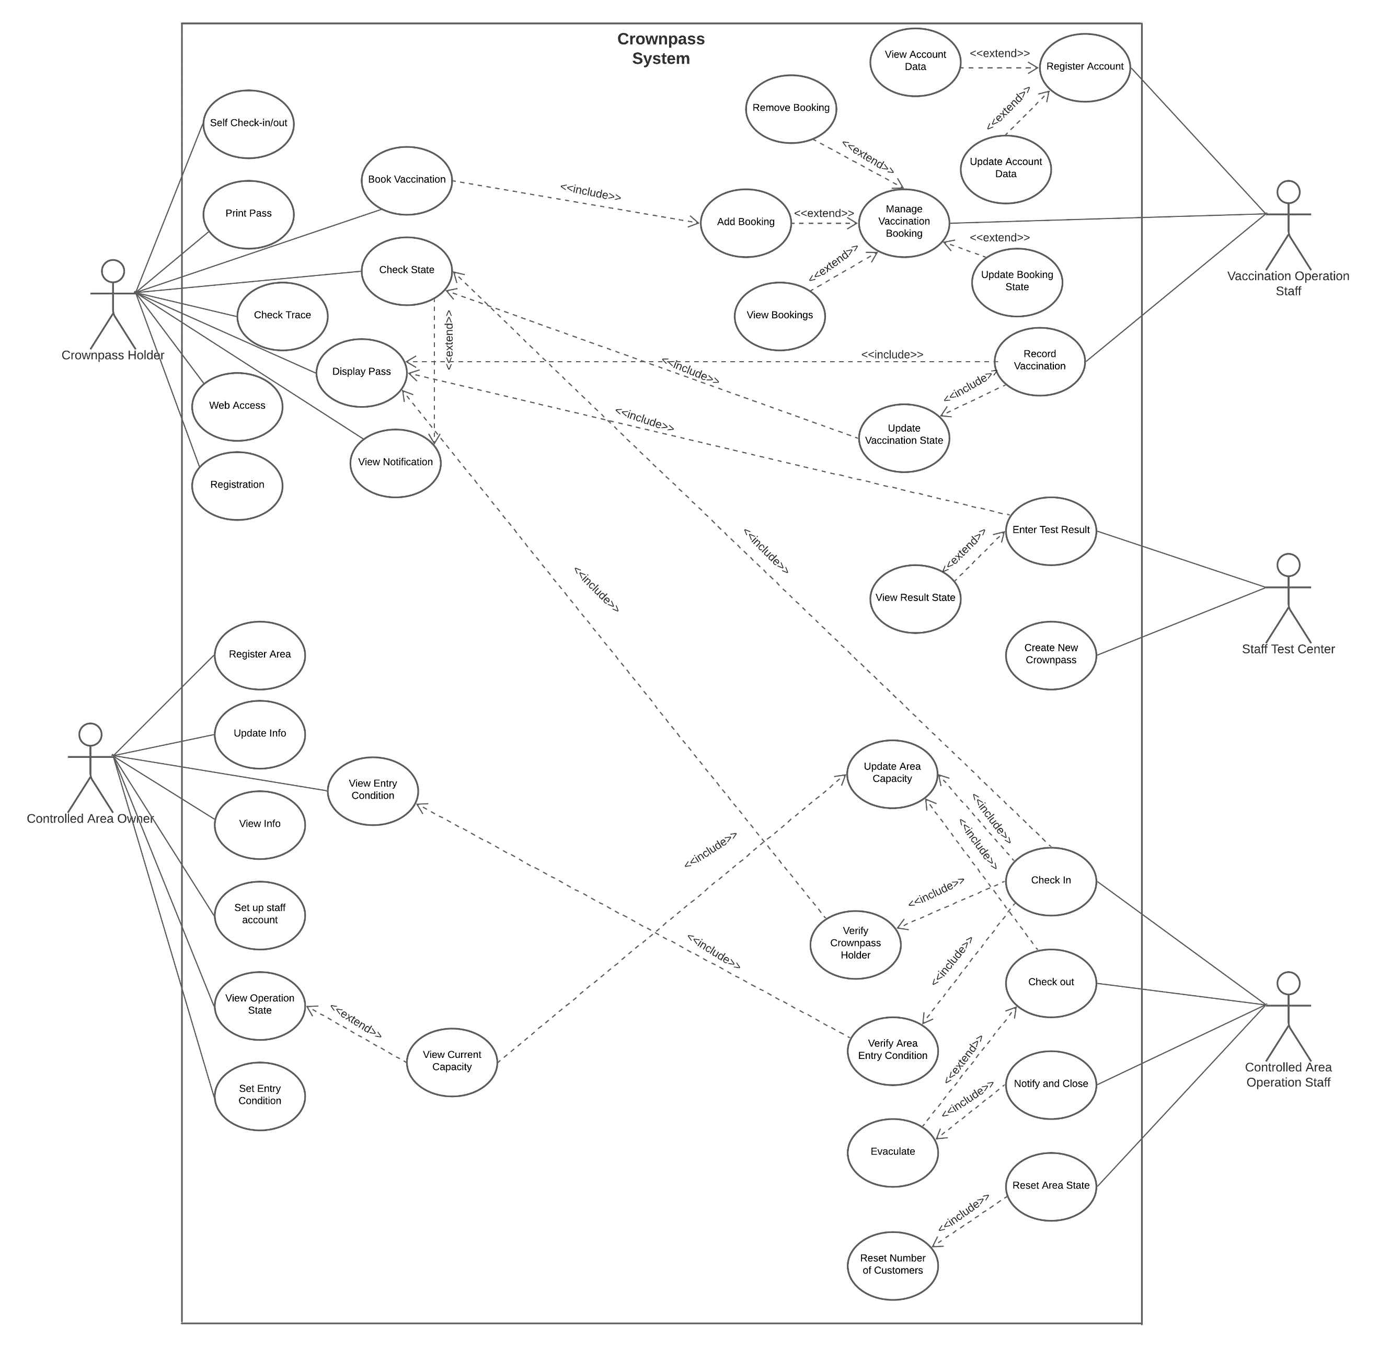

1c) NOTE: Spec does not require a overall class diagram, but in moodle and lectures we were advised to create one e.g. from week 7, moodle COMP6030:



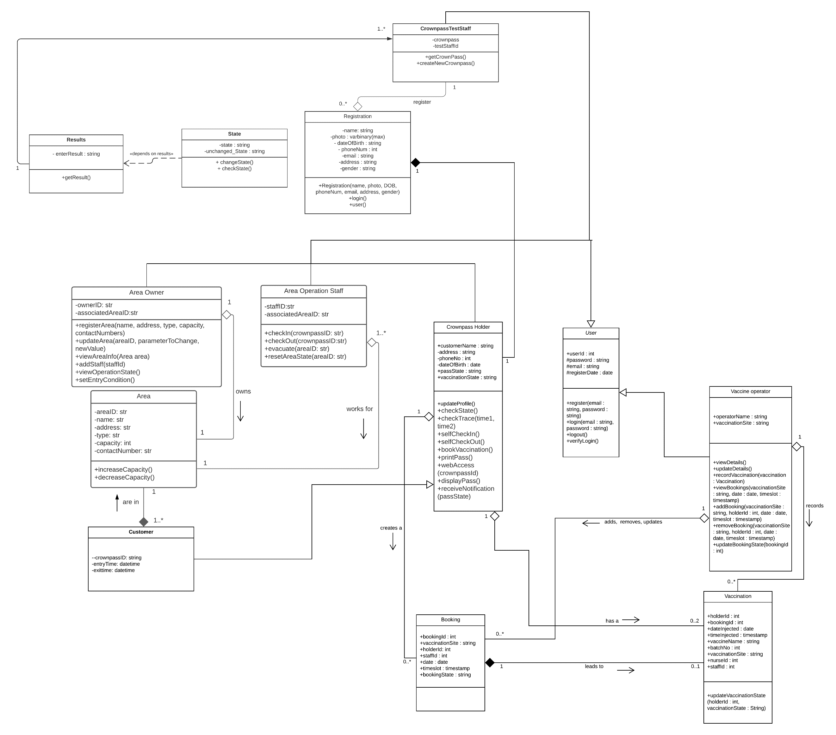

2a) Overall Architecture of the whole system

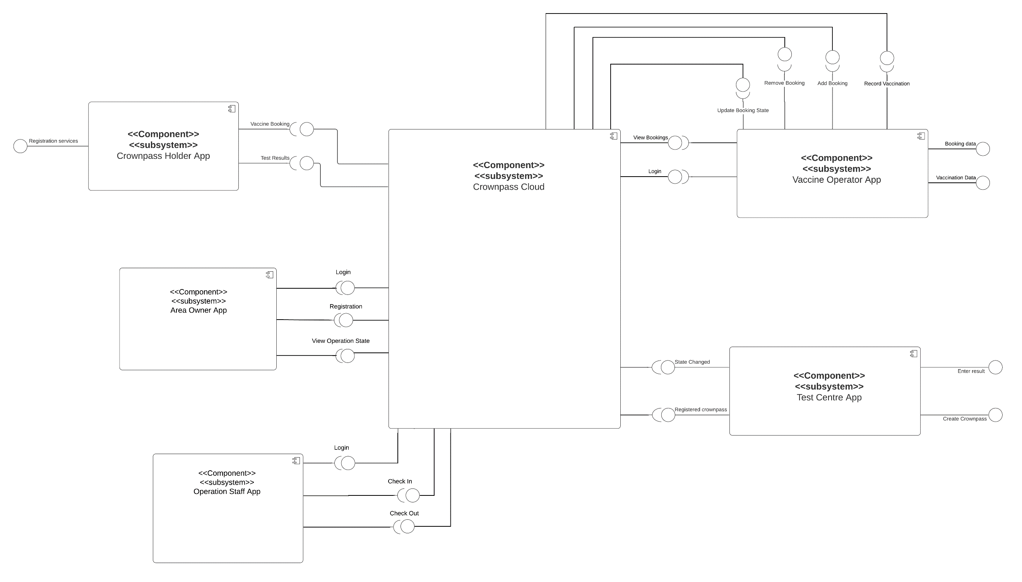

**Interface specification:**

Crownpass Holder App:

<<Interface>>

Test Results

+ViewResults()

<<Interface>>

Registration Services

+Registration(name: string, photo: varbinary(max) , DOB: string, phoneNum: int, email: string, address: string , gender: string, password: string)

+login()

+user()

<<Interface>>

Vaccine Booking

+BookAppointment( CrownPass Id: int, date: date, time: timestamp)

Vaccine Operator App:

|  |
| --- |
| <<interface>>  Login |
| +operatorLogin(email: string, password: string)  +operatorRegister(email: string, password: string)  +viewDetails()  +updateDetails() |

|  |
| --- |
| <<interface>>  View Bookings |
| +viewBookings(vaccinationSite: string, date: date, timeslot : timestamp) |

|  |
| --- |
| <<interface>>  Update Booking State |
| +updateBookingState(bookingId: int) |

|  |
| --- |
| <<interface>>  Add Booking |
| +addBooking(vaccinationSite: String, holderId: int, date: date, timeslot : timestamp) |

|  |
| --- |
| <<interface>>  Record Vaccination |
| +recordVaccination(vaccination: Vaccination)  +updateVaccinationState(holderId: int, vaccinationState: string) |

|  |
| --- |
| <<interface>>  Remove Booking |
| +removeBooking(vaccinationSite: String, holderId: int, date: date, timeslot : timestamp) |

Test Centre App:

Area Owner App:

|  |
| --- |
| <<interface>>  Owner Login |
| +ownerLogin(email: str, password:str)  +ownerRegister(email:str, Password:str) |

|  |
| --- |
| <<interface>>  Registration |
| +registerArea(name: str, address: str, type: str, capacity: int, contact_no: str)  +updateRegistrationData()  +viewRegistrationData() |

|  |
| --- |
| <<interface>>  View Operation State |
| +viewOperationState() |

Operation Staff App:

|  |
| --- |
| <<interface>>  Staff Login |
| +staffLogin(email: str, password: str) |

|  |
| --- |
| <<interface>>  Check In |
| +checkIn(crownpassId) |

|  |
| --- |
| <<interface>>  Check Out |
| +checkOut(crownpassID) |